Go to http://www.grochbiology.org/AgeHeightData.htm
Select all
Open Excel
Paste
Select one class worth of data without the average; here’s an example:

age (yr) | height (cm)
13.75 | 173.99
13.75 | 170.18
13.83 | 175.26
13.92 | 165.1
14.08 | 160.02
14.33 | 167.64
14.4 | 177.8
14.42 | 173.99
14.91 | 167.64
15 | 172.72
15.04 | 160.02
15.09 | 154.94
15.1 | 167.64
15.16 | 177.8
15.2 | 172.72
15.25 | 172.72
15.25 | 175.8
15.25 | 177.8
15.25 | 167.64
15.33 | 164.7
15.33 | 152.4
15.48 | 154.94
15.5 | 172.72
15.75 | 172.42
15.75 | 181.44
15.75 | 177.8
15.83 | 170.18
15.83 | 172.72
16.4 | 172.72
16.75 | 165.24
16.83 | 167.64
16.91 | 187.96
17.08 | 175.26

Highlight the data; select “chart wizard” from the top toolbar
Select x-y scatter, click next
Click next
Type in a title, label the x axis, the y-axis

Next, click finish, should look like this…

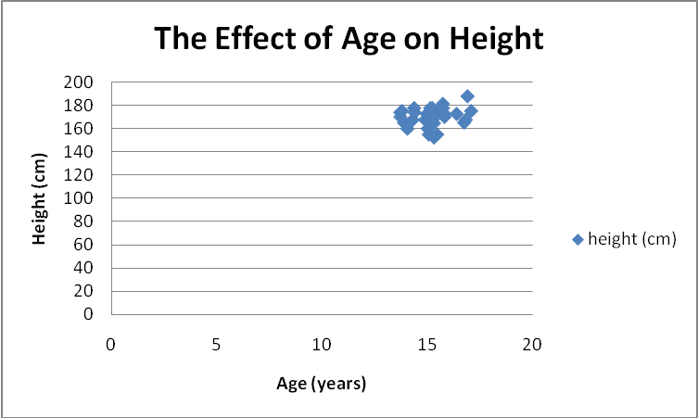

Next, click on a data point, right click and a window saying “add trendline” should pop up…

Linear should be highlighted,
Click on the options window and select add equation (two check boxes)
Graph should now look like:

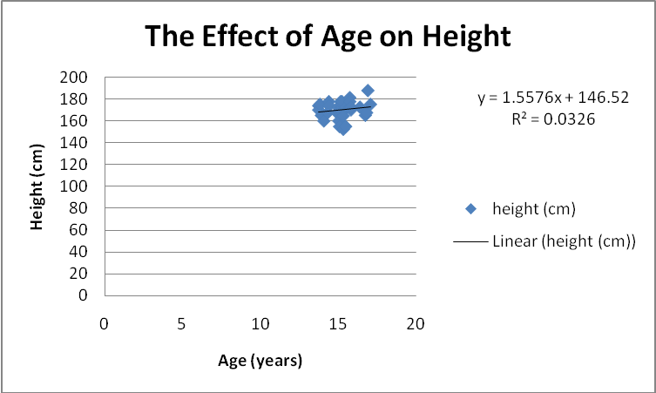

The trendline is very short only covering the data:
To extend the trendline forward and backwards…
Right click on the trendline, the window will pop up again “format trendline”, go back to option and predict forward 5 units and backwards 10 units… (note you can do all of this at once when you do the original trendline. The graph now looks like this:

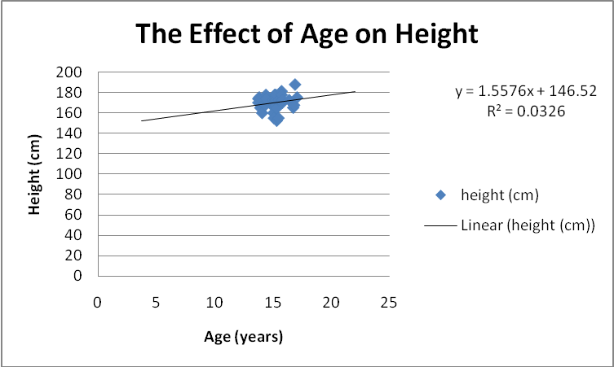

Now you can use the extended trendline to predict the height of a 5, 10, 15, and 20 year old.

